**DIGITAL HEALTH INSURANCE**

**Step 1: Defined the project scope**

* Created a Product Concept Statement for a mobile-first health insurance platform with AI-driven recommendations and seamless claims processing.
* Included AI-powered policy comparison, digital claims submission, health tracking, and 24/7 chatbot support.
* Project scope also contains business objectives, target market, key milestones and deliverables.
* Project Scope Document was compiled in Confluence as teams can easily contribute, edit, and review documents in real time as well as it seamlessly connects with other project management tools for workflow efficiency.

* The pdf document is added to the repository as well as the link is below:

<https://suryawanshiyash.atlassian.net/wiki/x/AoAg>

**Step 2: Conduct Competitor Research & SWOT Analysis**

* Analyzed digital health insurance platforms like Oscar Health and Bright Health, focusing on features, pricing, UX, and customer reviews.
* Identified strengths (AI-driven recommendations, mobile-first approach), weaknesses (regulatory hurdles, trust concerns), opportunities (rising demand), and threats (competition, policy changes).
* Evaluated industry trends and competitive gaps to refine the product strategy.

* The Competitor analysis and SWOT report are added to the repository as well as the link is below:

<https://suryawanshiyash.atlassian.net/wiki/x/AYAi>

**Step 3: Conducted Customer Research & Created User Personas**

* Researched and analyzed common complaints like complex plans, slow claims processing, and lack of policy clarity.
* Developed detailed profiles, such as Alex (35, freelancer), highlighting pain points (policy comparison challenges) and needs (transparent pricing, AI-driven suggestions).
* Focused on real customer frustrations to align product features with user expectations.

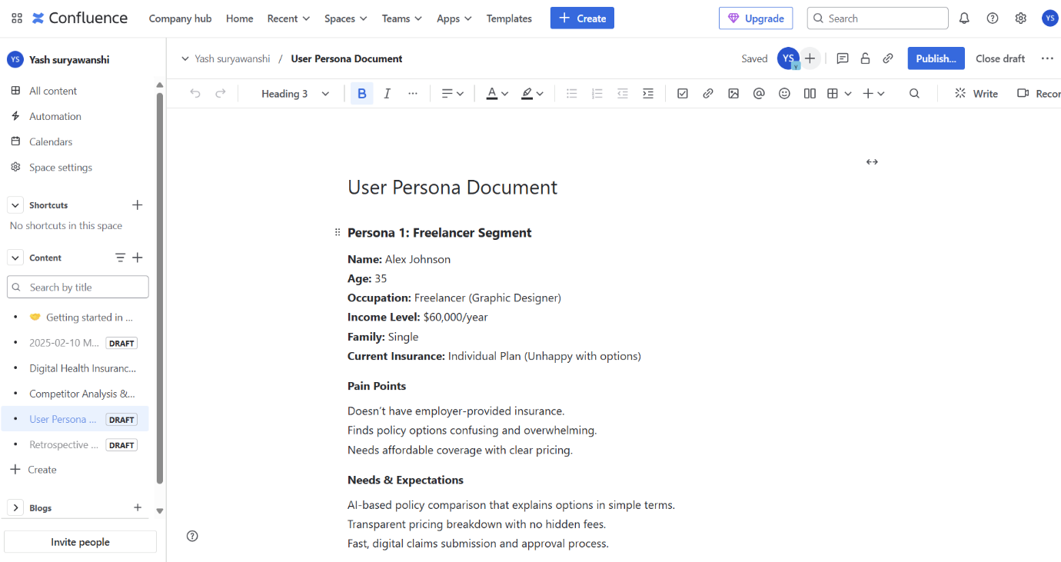

* The user persona document is added to the repository and the link is below

<https://suryawanshiyash.atlassian.net/wiki/x/EoAg>

**Step 4: Developed a Project Roadmap & Set Milestones**

* Outlined key stages, including Market Research (Week 1), UI/UX Design (Weeks 2-3), MVP Development (Months 1-2), Beta Testing (Month 3), and Full Launch (Month 4).
* Targeted wireframe completion by Week 2, prototype by Month 1, beta testing by Month 3, and final launch by Month 4.
* Mapped deliverables to ensure a smooth development and release process.

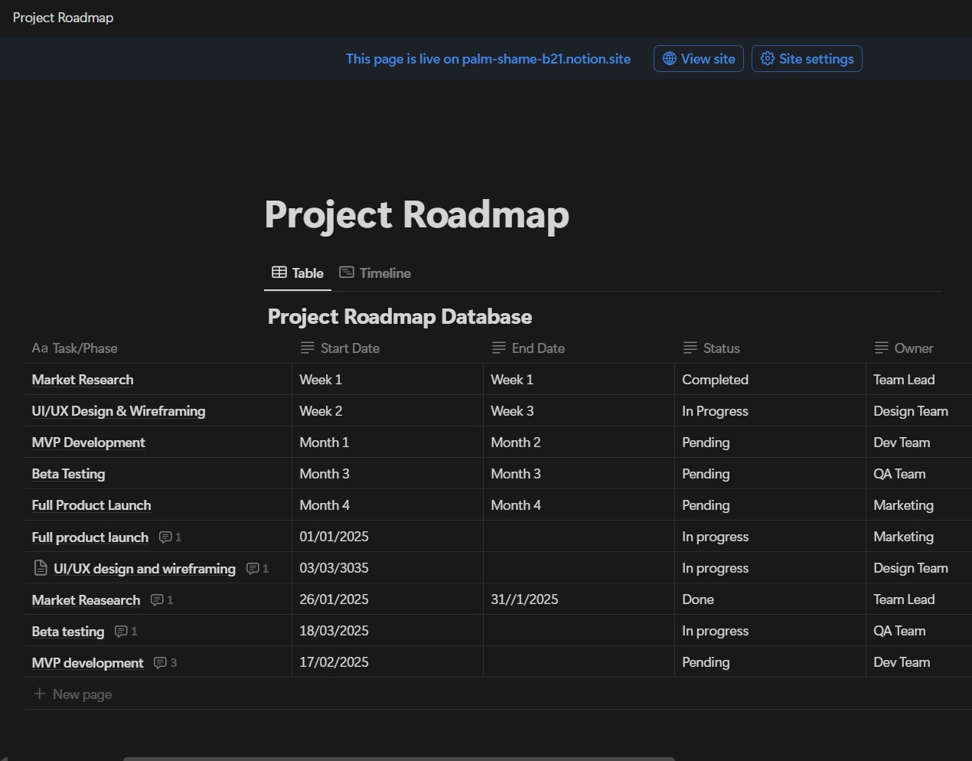

* Project Roadmap Visualization was documented in Notion and the link is below

<https://palm-shame-b21.notion.site/Project-Roadmap-196e2210927e80068995c6ca5ab56e4b?pvs=4>

**Step 5: Identify Risks & Mitigation Strategies**

* Addressed challenges like HIPAA compliance, cybersecurity threats, low customer trust, and complex onboarding.
* Implemented end-to-end encryption, regular security audits, transparent pricing, and UI/UX simplification.
* Focused on data protection and trust-building measures.

* Risk assessment report was documented on notion and the link is below

<https://palm-shame-b21.notion.site/Risk-Assessment-Report-197e2210927e80979653f12204375f41?pvs=4>

**Step 6: Summarised Market Research Findings**

* Summarized market demand, competitor analysis, user personas, and risks/compliance requirements.
* Organized data for clarity and decision-making.
* Used PowerPoint with key data points for better understanding.
* The Market research PowerPoint is added to the repository.

**Step 7: Conducted Retrospective & Planned Next Steps**

* Reflected on valuable insights, challenges faced, and areas for improvement in the research process.
* Planned UI/UX wireframing, business model development, and partnership strategies.
* Used research findings to guide the next phase of product development.

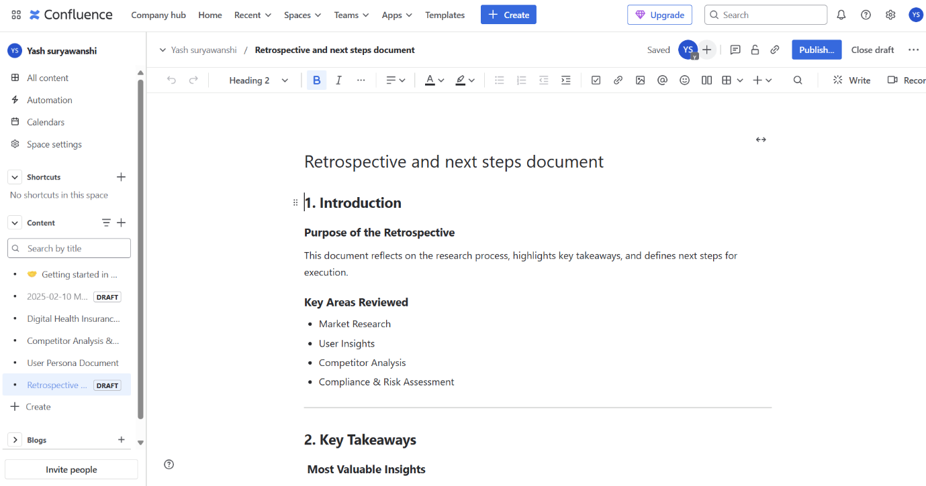

* Retrospective and next steps report is added to the repository and the link is below

<https://suryawanshiyash.atlassian.net/wiki/x/AQAt>